Programming IDE: Android Studio or Kotlin Playground

- Write a Kotlin program that generates a number-Z pattern based on the given number. (50pts)
- Assume we only use the number >= 3
- Use basic loops (for, while, etc.)
- No hard-coded solutions are allowed

Use the following code template.

val num=8 // Change this line for testing
… implement here!

Output examples)
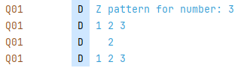
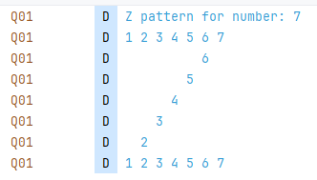
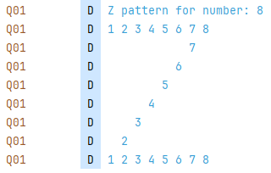
* Submit your kt file (for Android Studio) or txt file (for Kotlin playground)
to eClass – Assignment – Q1P1

- Write a Kotlin program that can identify and print prime numbers from the given list of integers (50pts).
- Define “isPrime” function: Write a function called isPrime that takes an Int and returns a Boolean. This function should correctly identify if the given number is prime.
- Generate a list: Create a list of 10 random integers, with each number ranging from 1 to 100.
- Filter the list: Use the filter function to process the list you generated. For filtering, use isPrime function you defined.
- Print the result: Print both the original list and the new list containing only the prime numbers.

Use the following code template.

fun isPrime … { // Define “isPrime” function
// …
}

…

val numbers = … // Generate a list
println("Original List: $numbers") // Print the original list

val primeNumbers = numbers.filter… // Filter the list

println("Prime Numbers: $primeNumbers") // Print the prime number list

Output examples)

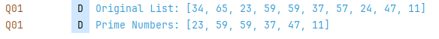

* Submit your kt file (for Android Studio) or txt file (for Kotlin playground)
to eClass – Assignment – Q1P2

